18ECC201J - ANALOG ELECTRONIC CIRCUITS LABORATORY
SEMESTER- IV

ACADEMIC YEAR: 2021-2022 EVEN
NAME:
REG.NO: RA

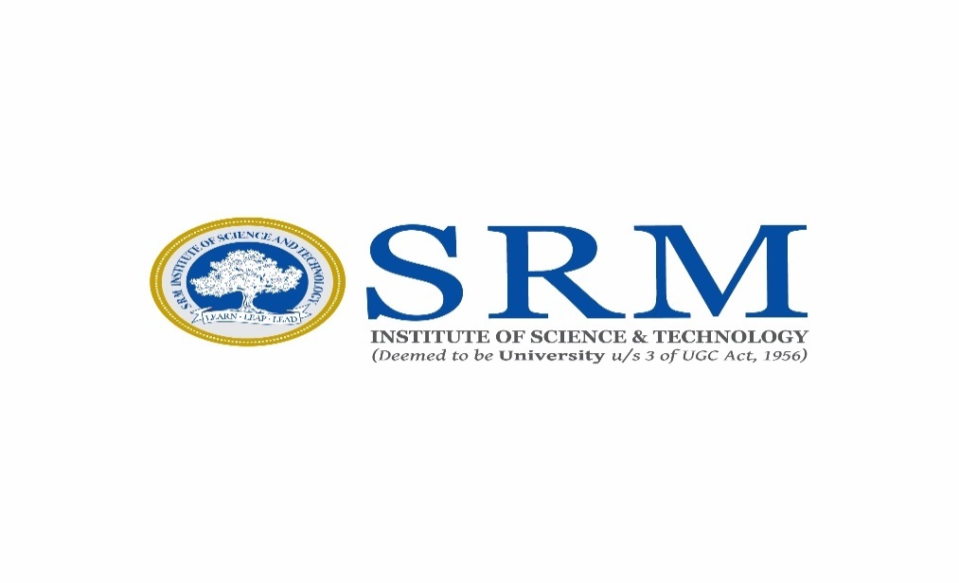

DEPARTMENT OF ELECTRONICS AND COMMUNICATION ENGINEERING

COLLEGE OF ENGINEERING AND TECHNOLOGY
SRM INSTITUTE OF SCIENCE AND TECHNOLOGY
(Under SECTION 3 of the UGC Act, 1956)
S.R.M. NAGAR, KATTANKULATHUR – 603203.
CHENGALPATTU DISTRICT

JUNE 2022
Name: Class: II - ECE- C Sec
Reg.No: RA Branch: ECE
Expt. No. | Date of Performance | Title of Experiment | Marks Obtained (40)
1
2
3
4
5
6
7
8
9 (a&b)
10
11
12
Average

 |  | Mini Project –

Lab In-Charge

